

CHURCH OF CHRIST
TIPITAPA, KM 20
iglesiadecristokm20@gmail.com

To : Brother
From : Tipitapa Church of Christ
Matter : Report of June, 2012
Date : Monday, the 2nd of July of 2012
Dear brothers.
Our greetings in Christ for all of you.
We are sending to them the report of the baptisms realized in June, 2012.
In Tipitapa four baptisms were realized.
In the Prison three baptisms were realized.
Is realized in this month the opening of a new work at little distance of Tipitapa, in a place known as VILLA SOLARIDAD.
The results of the opening of this new work are; 13 baptized persons and they will be congregating in house of a brother who lives there.
The days of meeting are: On Sundays, adoration
On Wednesday, class Biblical and visit that there will be doing the brother in charge of this new work. On Monday, the 16th of July we will be preaching in the vale of Zinica, we will be preaching all the persons of there. We request his prayers so that the gospel is preached to all the persons of Tipitapa, vales, regions and peoples. On Monday, the 16th of July we will be preaching in the vale of Zinica, we will be preaching all the persons of there. We request his prayers so that the gospel is preached to all the persons of Tipitapa, vales, regions and peoples. Etc

NAMES OF THE BAPTISMS IN TIPITAPA
Number | Name | Last name | Date
1 | Roberto | Sequeira Alemana | 11/ June / 2012
2 | Tania | Loaisiga Raudez | 11/ June / 2012
3 | Sebastian | Valle Velásquez | 17/ June / 2012
3 | Romeo  PHOTOS OF THE BAPTISMS IN TIPITAPA | Blandon Oliva | 17/ June / 2012

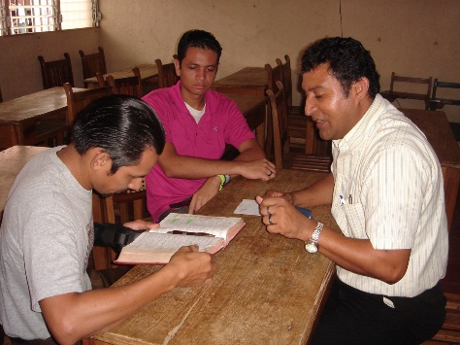
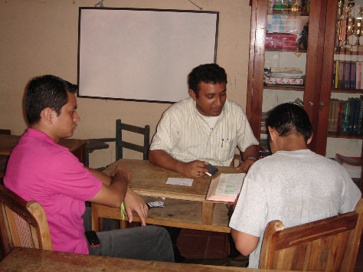

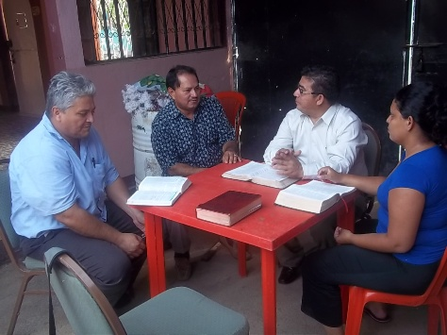
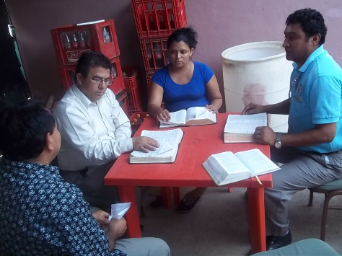

The brother Francisco, Elvis and Marvin preach; to Dr. Roberto Sequeira and to his wife and then
they are baptized
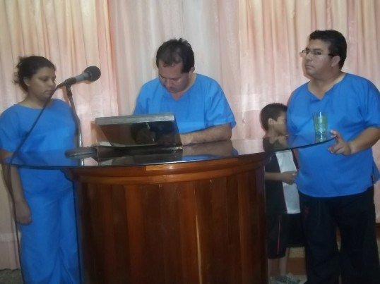
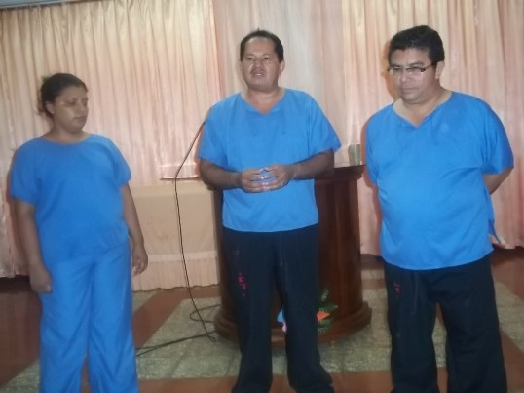

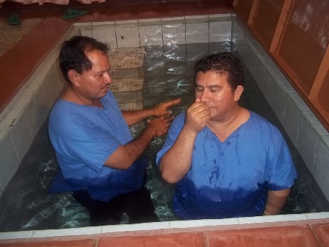
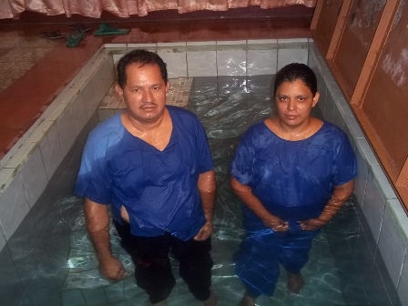

The Doctor Roberto and his wife Tania are baptized by the brother Elvis

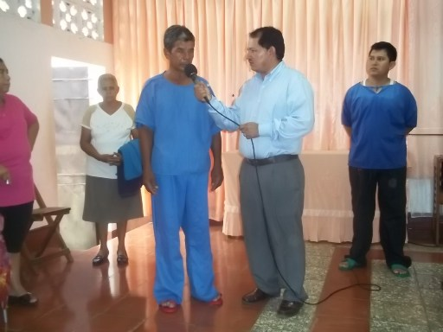
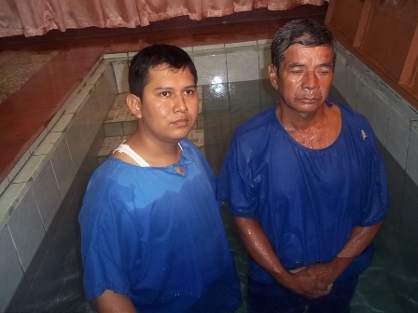

Here the brother Reinaldo baptizes Romeo in the baptistry of Tipitapa.
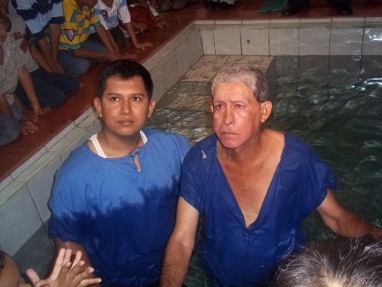

Here the brother Reinaldo baptizes Sebastian in the baptistry of Tipitapa


CHURCH OF CHRIST

In the Prison
IN SYSTEM PENITENSARIO THE MODEL

Dear brothers.
Report of the Prison.
On Tuesday, the 26th of June we went to the visit in the prison preaching the gospel to the interns of there and shared great happiness with our brothers of the church also and gave to all many food and refreshments.
Result of the preaching, three persons were baptized for the pardon of his sins.
Seven brothers gave them freedom and are delivered to them the directions of Christ's churches so that they could congregate.
Also a leader of the church there in the prison will go out at freedom in four months and he will be congregating together with his family in Tipitapa.
Christ's church in Tipitapa realizes works with two pavilions in the Prison.
The pavilion number 9
The pavilion number 13

NAMES OF THE BAPTISMS IN THE PRISON
Number | Name | Last name | Date
1 | Julián | Picado Meza | 26/ June / 2012
2 | David | Vargas Vegas | 26/ June / 2012
3 | Pedro | Benavides Cruz | 26/ June / 2012
Photos of the brothers that we visit the Prison
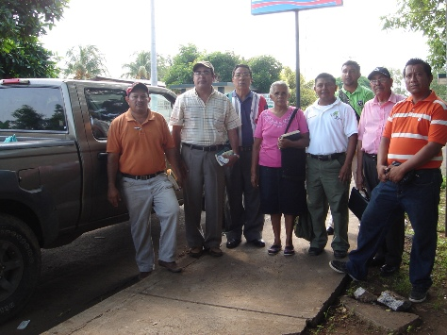
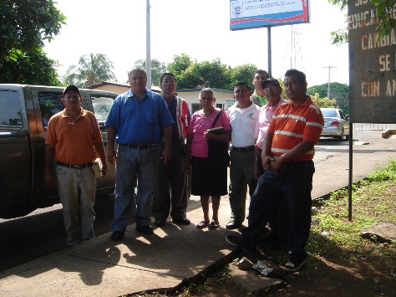

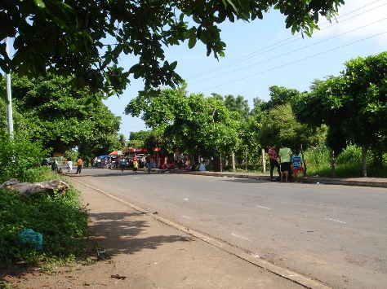
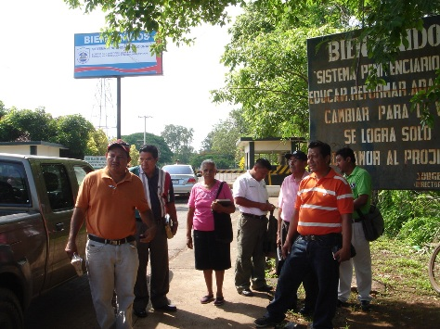

Group of brothers in the entry of the Prison.
We cannot enter to inside the prison with camera photographic, it is prohibited.

