


Church of Christ
Tipitapa Km. 20
E: mail: iglesiadecristotipitapa@yahoo.com

TRIP TO HONDURAS TO HELP IN A CAMPAIGN

We were invited to preach for one week to Tegucigalpa Honduras in a campaign that is realized in a place called Mololoa. We travel five brothers and the wife of the brother Francisco Cajina. 16 baptisms were realized in these days. The brothers that we travel to Honduras were: Francisco, Ramon, Reynaldo, Mario, Marvin and the sister Sabina. The preacher of this church invited us and received us very well and the church is located in one a zone of very poor persons and for us this experience of the trip was very nice and to preach the gospel to all these persons with longing for listening to the gospel of our Lord Jesus Christ.

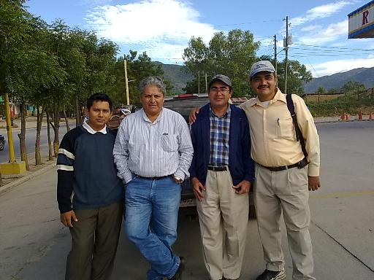
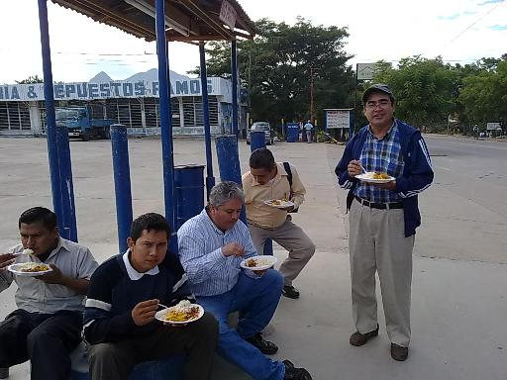
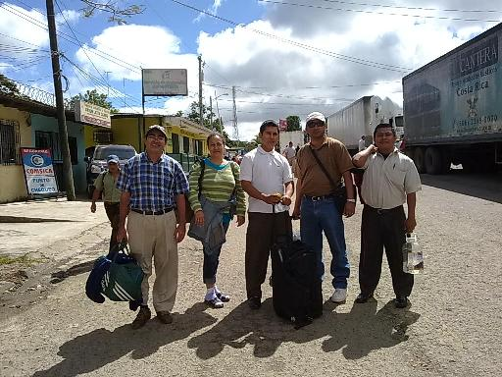

This is the border of Nicaragua with Honduras and here we are having lunch

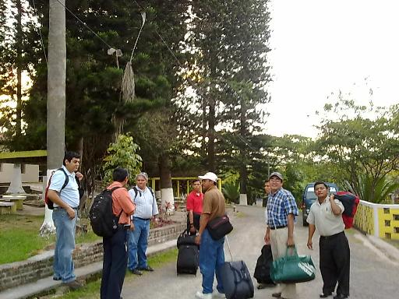
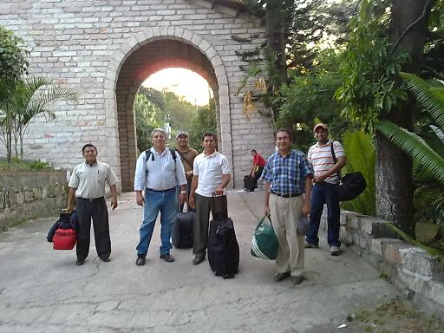
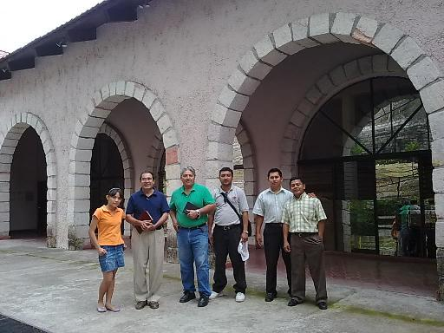

Here we are in the Institute Baxter de Honduras where we stay

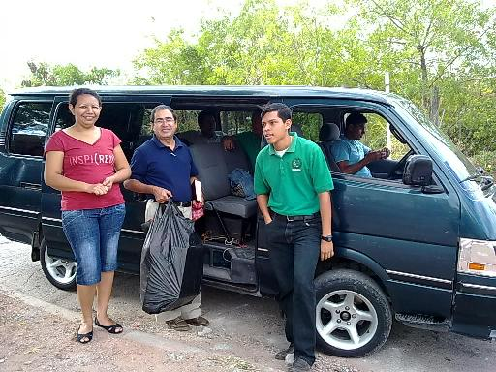
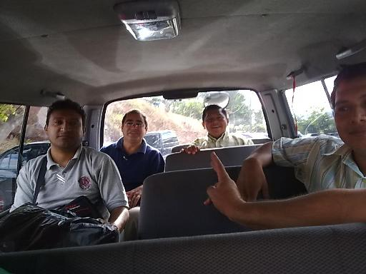
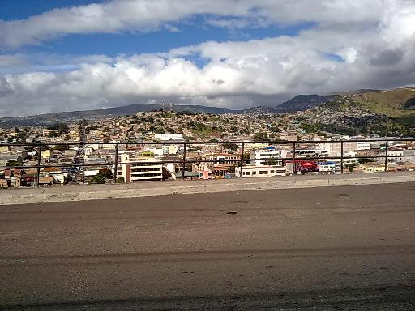

In this bus we were travelling from the Institute Baxter up to the church in Mololoa every day

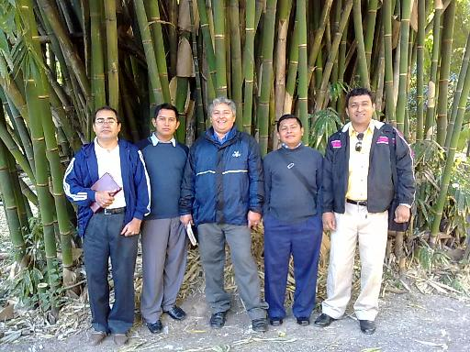
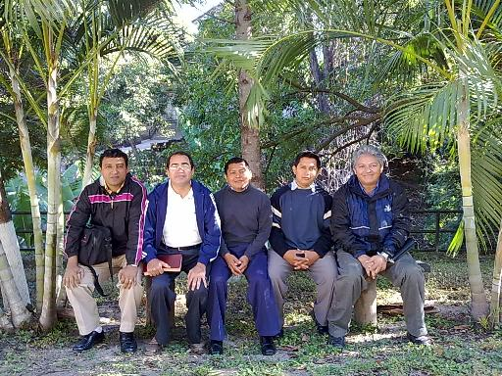
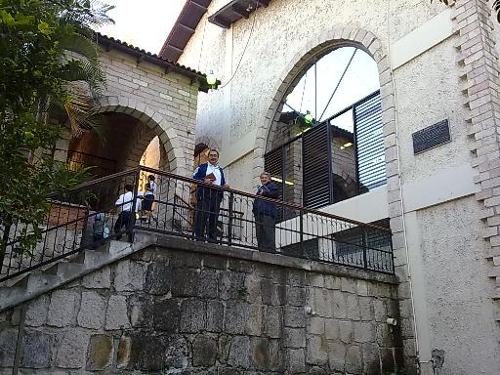

From left side to right hand: Marvin, Ramon, Mario, Reynaldo and Francisco, here we are in the Institute Baxter

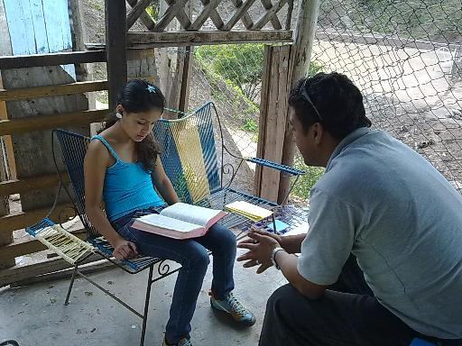
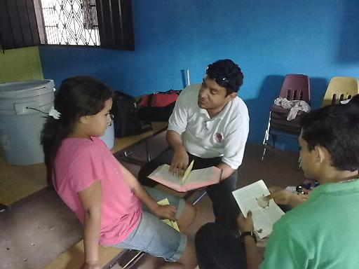
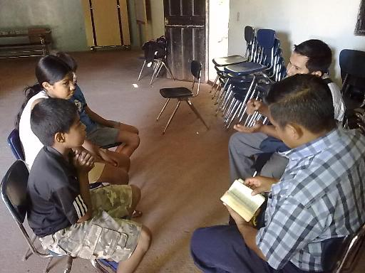

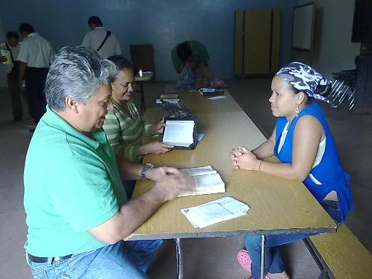
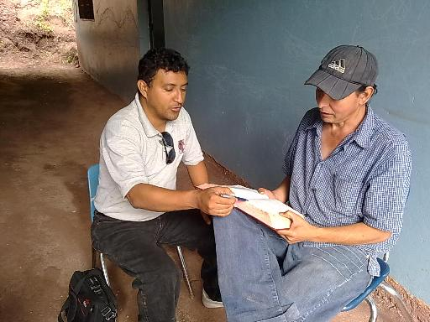
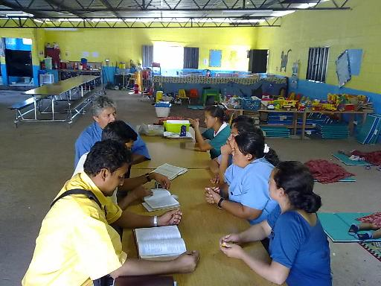

Here the persons of Mololoa are preached

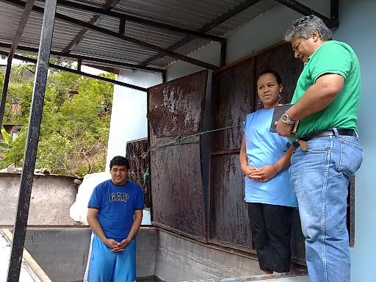
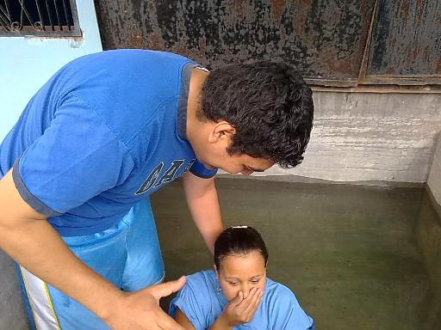
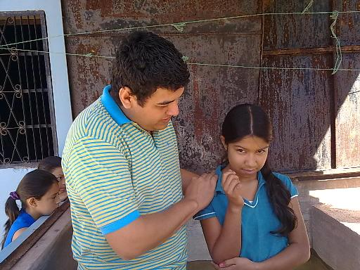

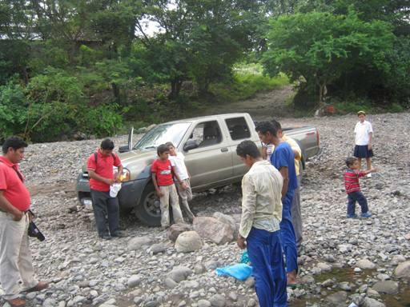
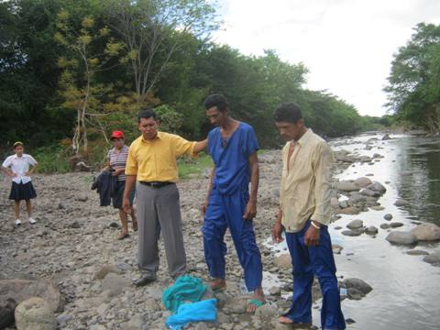
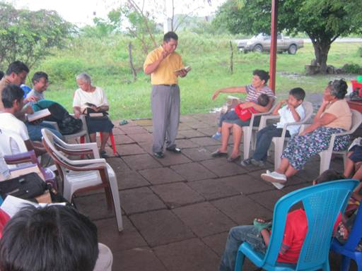
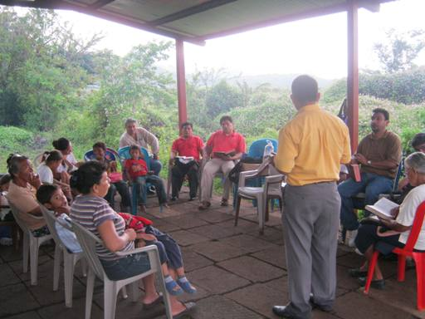
The church in Tipitapa, assembled on a Sunday in the morning

Here evangelista Noel Aragon de Mololoa realizes a baptism

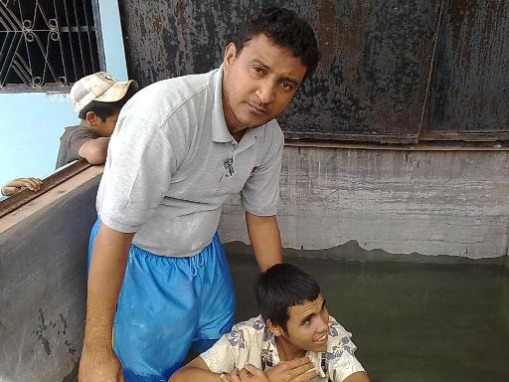
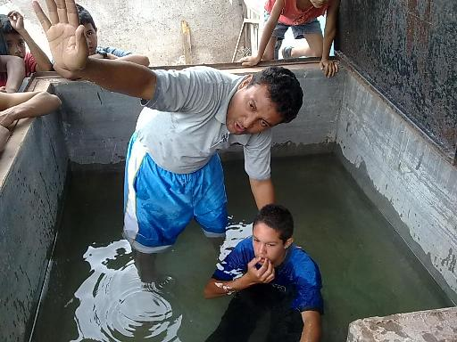
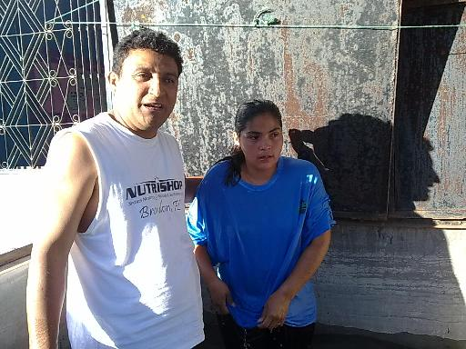

Here the brother Marvin of the church in Tipitapa realizes a baptism in Mololoa, Honduras

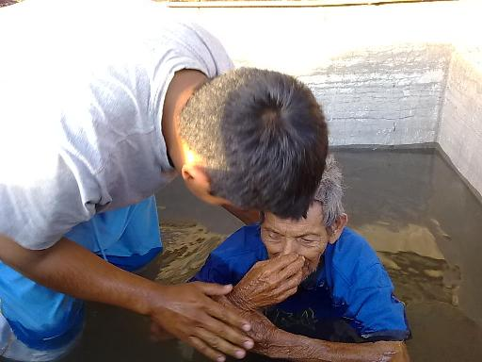
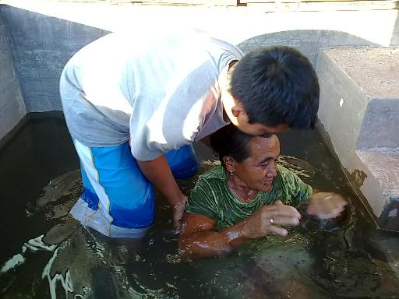
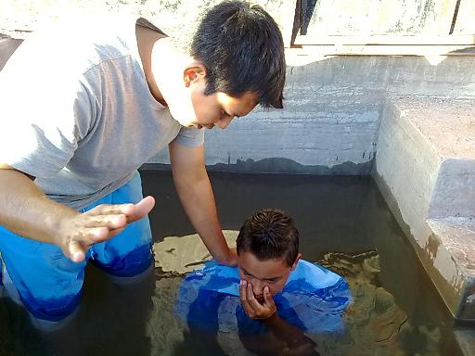

Here the brother Reinaldo of the church in Tipitapa realizes a baptism in Mololoa, Honduras

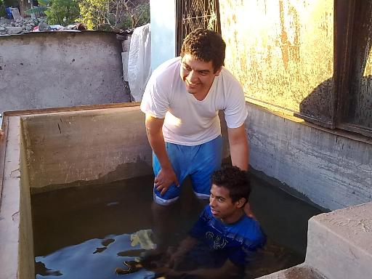
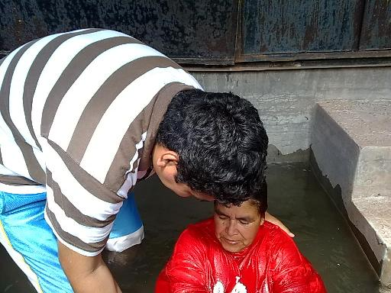
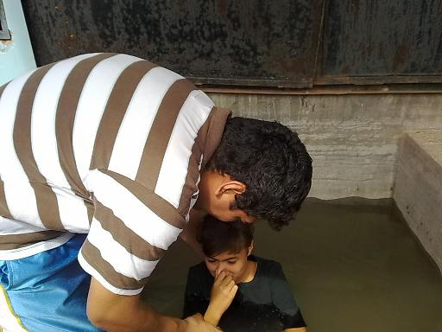

Here the Evangelist of Mololoa, Noel Aragon realizes a baptism

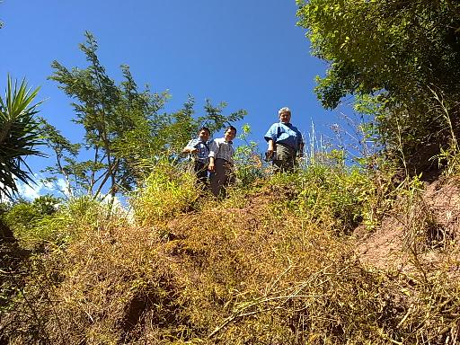
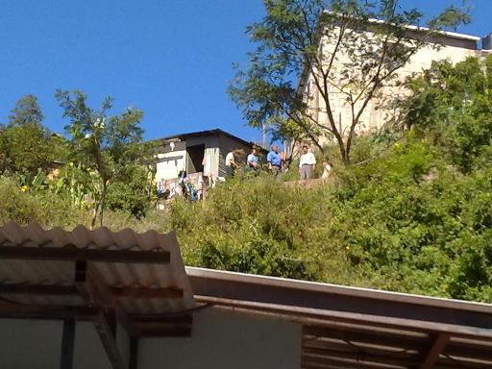
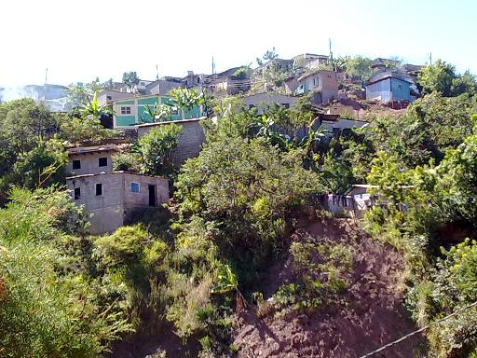

Here the brothers walk along a hill to go to preach. Houses of Mololoa, merely to the shore of a hill

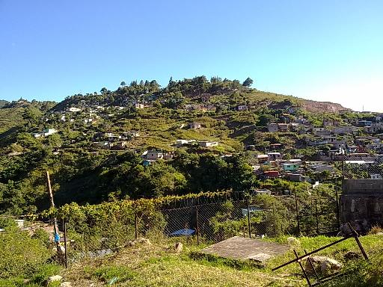
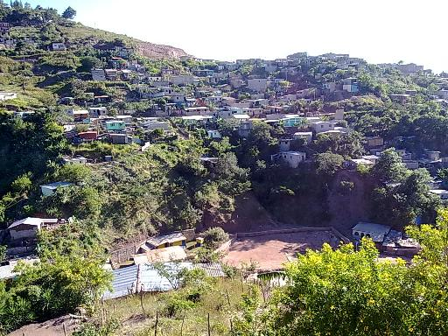
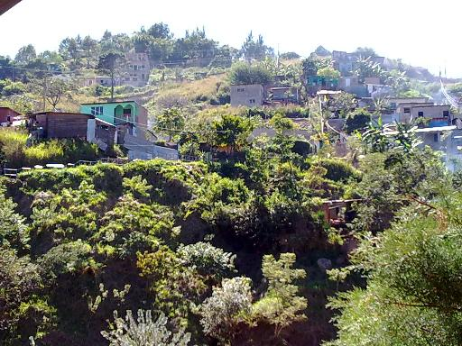
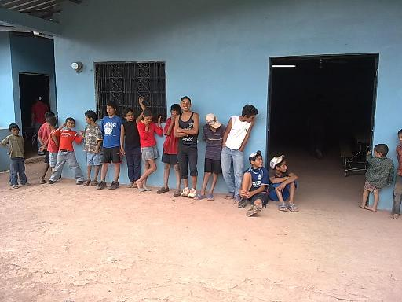
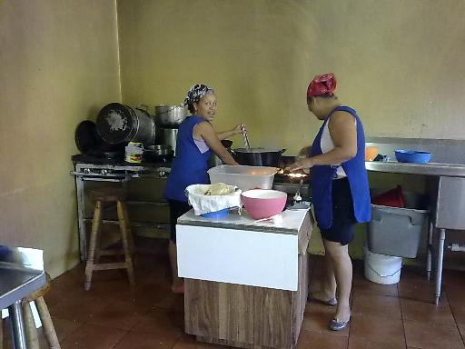
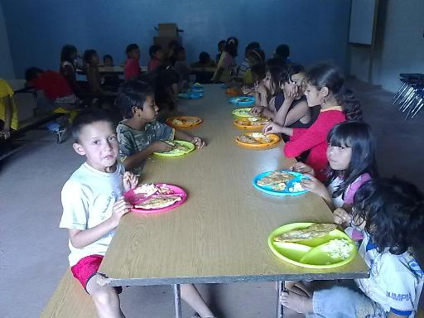
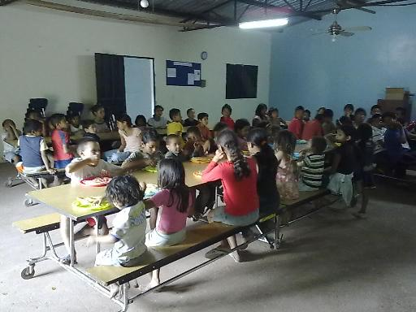
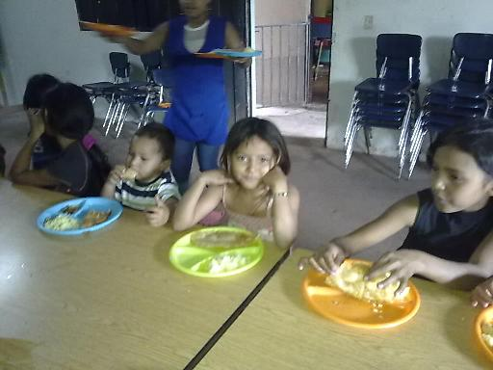
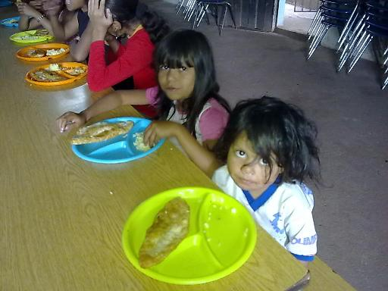
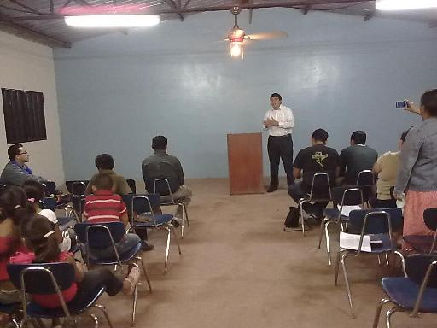
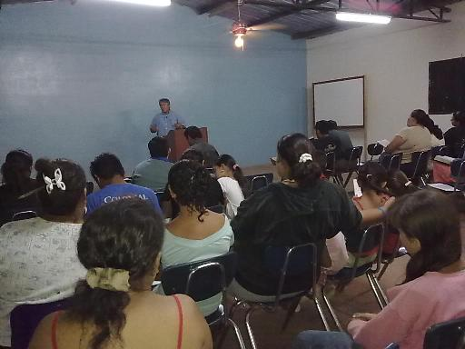
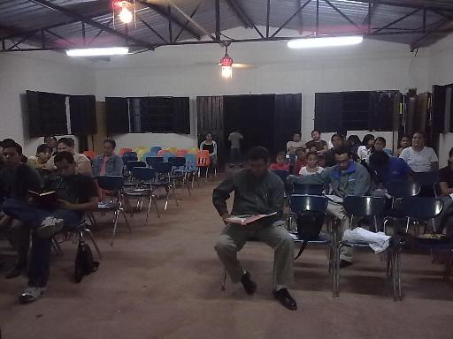
Houses of Mololoa, merely to the shore of a hill
The church in Mololoa has an infantile dining room where every day they feed poor children. Food is delivered to 160 daily children and also the God's word is taught to these children. The sisters of garments blue it prepares the food for all these children.
In the night of campaign in the church in Mololoa.
This is our work and it makes us happy very much to send report to all of you: God blesses them.

